**Hannah Green**

**E21**

**A & D - Analysis and Design Unit**

**A.D 1 A Use Case Diagram**

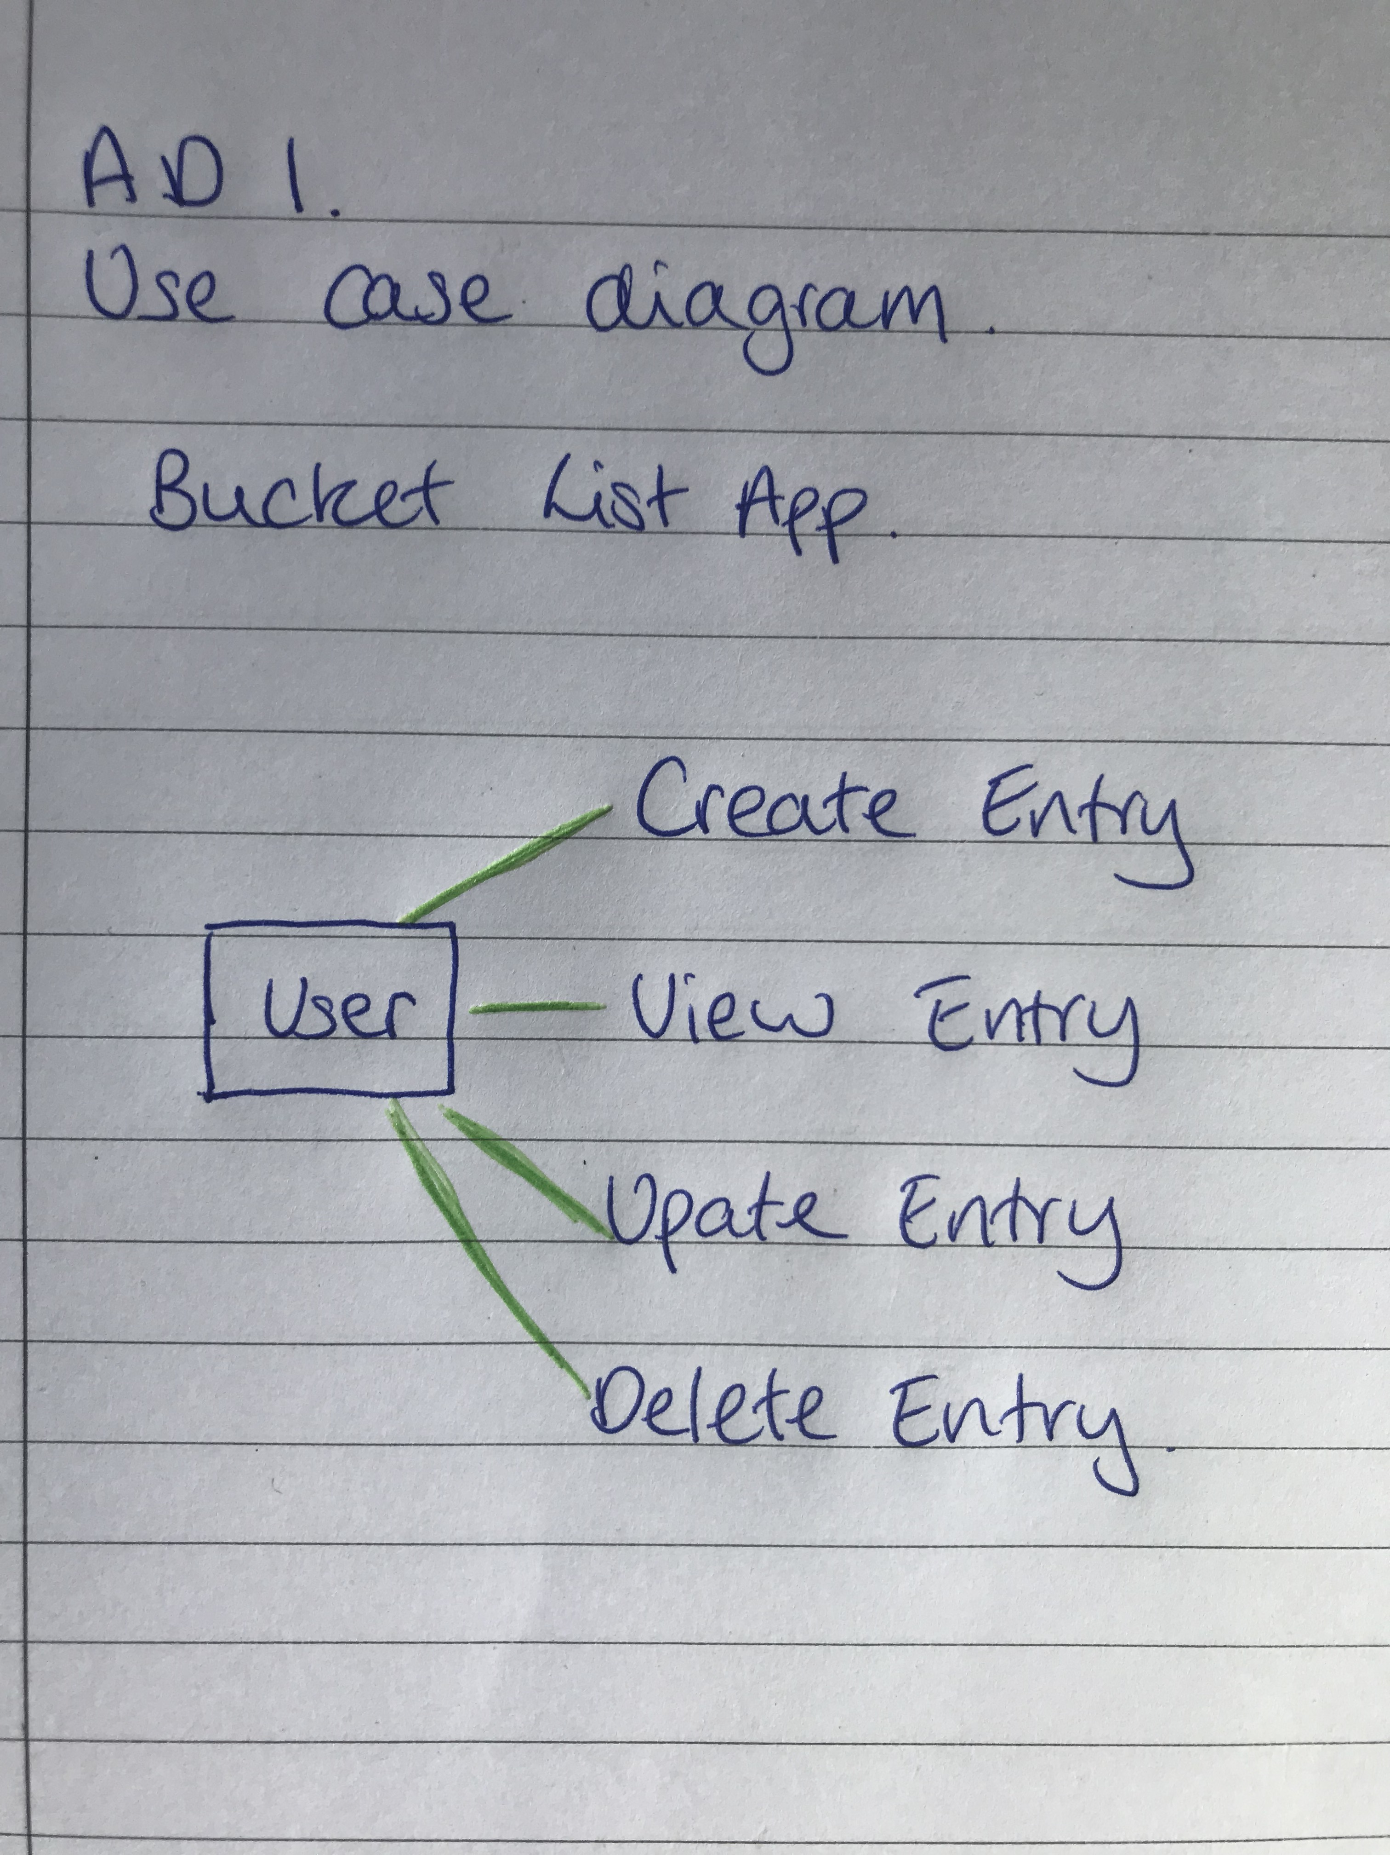

**A.D 2 A Class diagram.**

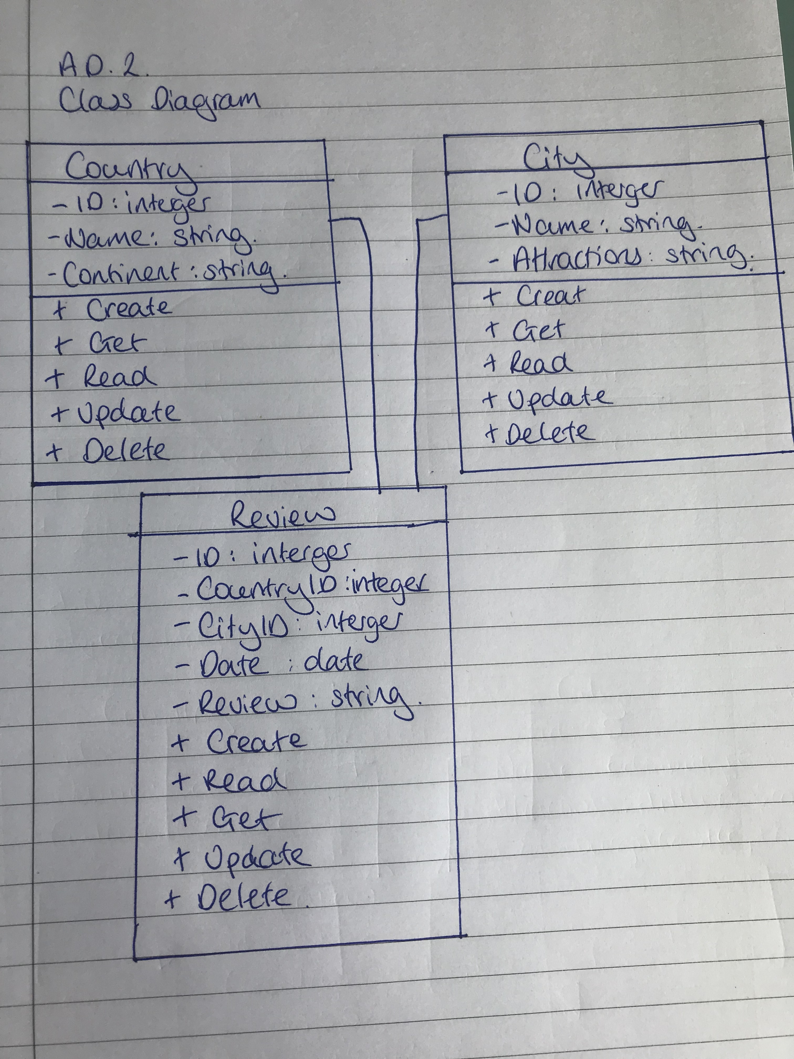

**A.D 3 An Object diagram.**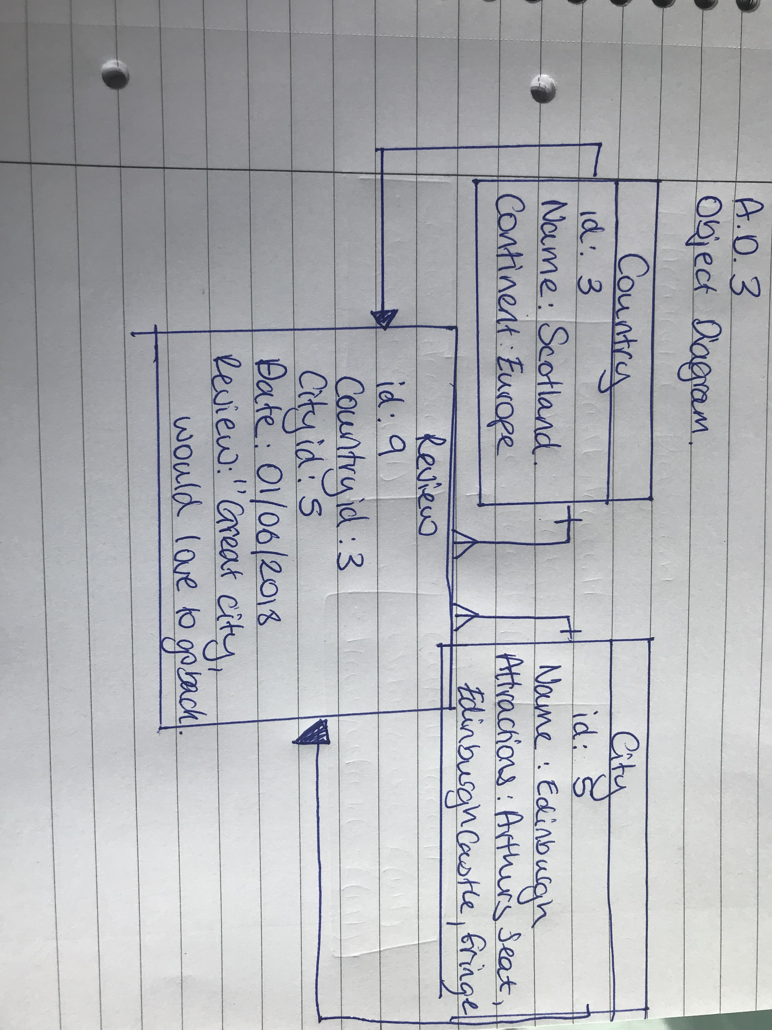

**A.D 4 An Activity Diagram**

**A.D 5 An Inheritance Diagram**

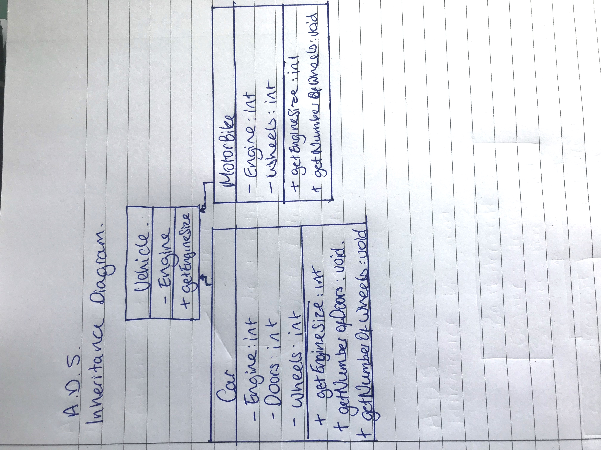

**A.D 6 Produce an Implementations Constraints plan detailing the following factors:**

● Hardware and software platforms

● Performance requirements

● Persistent storage and transactions

● Usability

● Budgets

● Time

|  |  |  |
| --- | --- | --- |
| **Topic** | **Possible Effect of Constraint on the Product** | **Solution** |
| Hardware and software platforms | Server with less than 8GB RAM – Could slow the app’s performance speed | Renting an online server which meets the minimum requirements |
| Performance requirements | The app does not open in every browser, making accessibility challenging | Using semantic HTML to make clear to the browser the content and meaning of the page |
| Persistent storage and transactions |  |  |
| Usability |  |  |
| Budgets |  |  |
| Time |  |  |